Lab 08 - L.A.M.P and Traditional Web Vulnerabilities
Table of Contents
Introduction 1
Deployed Server Configuration 1
Install Apache 1
Install PHP 3
MySQL 4
Simple Login 4
Login Database 4
Test the Configuration 5
Setting Up SSL 5
Web Expansion 10
SQL Injection 11
Add Rules for WWW for Outside/Nagios Check 12

Introduction
This week we are going to install a web and file server called Apache HTTP Server ("Apache"). It is a popular Linux web server, and it can do several things, such as HTTP and HTTPS for web and FTP for files. We will also be installing MySQL and PHP, which are a common set of tools for web servers. This set of tools is often referred to as a LAMP stack, or Linux-Apache-MySQL-PHP.

Deployed Server Configuration
  - Configure the new lamp server, as our www machine
    - VM name: cpre230_[netid]_www
    - Credentials: cpre230/cpre230
    - Set MAC address reservation using the table below

MAC address | IP address | Hostname | Description
From vSphere client | 192.168.1.202 | www | Ubuntu server - www

    - Power on the machine.
    - Set the hostname to www.
    - Verify the IP address.
    - Reboot.
    - Update and upgrade using apt.

Install Apache
- From your www server, run the following command.
sudo apt install apache2
- We need to change the web site to only run using IPv4 traffic. Edit the file /etc/apache2/ports.conf
- Prepend 192.168.1.202: to each of the listed ports and save the file.
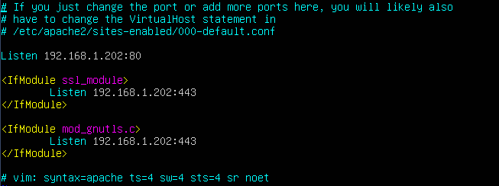
- To verify that apache2 was properly installed, we will visit the default website on our local machine with a text-based web browser called Lynx. To install Lynx, run the following command.
sudo apt install lynx
- Test that Lynx works by visiting a website.
lynx www.iastate.edu
- You should now see a textual representation of the Iowa State homepage. You can press 'q' then 'y' to exit Lynx.
- Now, to view our default homepage, you could issue one of the following commands. The first two will simply download a copy of the source HTML that we can browse, however, with Lynx, we are able to actually interpret and view the rendered version of the HTML. Use Lynx to visit check the configs. DO NOT RUN THESE AS ROOT. MUST BE cpre230 user
  - curl www.studentXX.230.com
  - wget www.studentXX.230.com
  - lynx www.studentXX.230.com
- You should see the following; this is the default webpage displayed by Apache after installation. We will create our own basic website shortly. Take a screenshot!
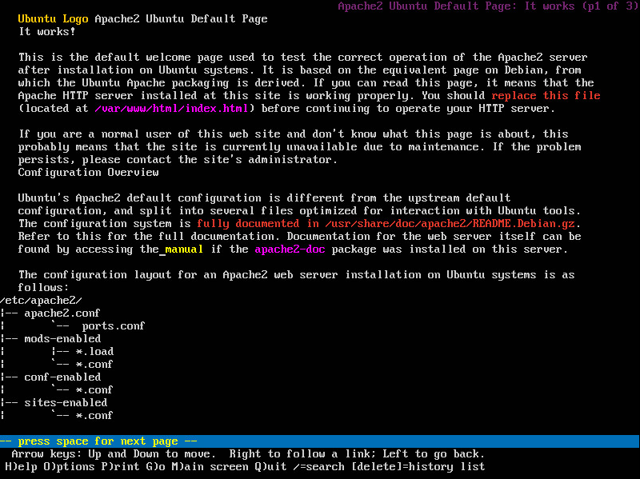

Install PHP
PHP is a programming language that allows us to create dynamic web content. PHP code is executed on the server and is used to generate the HTML that is displayed to the end user in the web browser. We will use PHP to create a basic login page that authenticates against a MySQL database, which we will create in later steps.

- Install PHP with MySQL capabilities with the following command.
sudo apt install php php-mysql libapache2-mod-php
- Create a file called helloworld.php in /var/www/html with your favorite text editor.
sudo vim /var/www/html/helloworld.php
- Put the following code in the new file.
<?php print "Hello, world!"; ?>
- Use Lynx to view the page.
lynx www.studentXX.230.com/helloworld.php.

View your webpage from your desktop box.
- Open Firefox.
- Navigate to www.studentXX.230.com/helloworld.php.
- Take a screenshot.

MySQL
Return to your newly installed www server to install MySQL.
sudo apt install mysql-server mysql-client

Simple Login
We will be connecting to a remote repository to download the necessary PHP scripts needed to login and connect to the database we will build in subsequent steps.

scp protocol will be used to transfer these files from the remote server to our own. It follows the same convention as normal cp as in ”cp [source] [destination]”, however you can have either of the source or destination over the internet as denoted by user@host:location. We have the case where the source is over the internet. scp is built upon ssh, which requires authentication, so we have provided the user repo230 for you to authenticate with and transfer the correct files over.

- Issue the following commands to retrieve the necessary files. The password for the repo230 user is repo230. If prompted to trust the server's fingerprint, say yes.

sudo scp repo230@homework.230.com:~/lab08/part1/*.php /var/www/html/

sudo scp repo230@homework.230.com:~/lab08/part1/vars.inc /var/www/html/

These files should now be placed into the directory /var/www/html.
- After downloading these scripts, head on over to your desktop machine and visit www.studentXX.230.com/login.php. You should see a page like this.
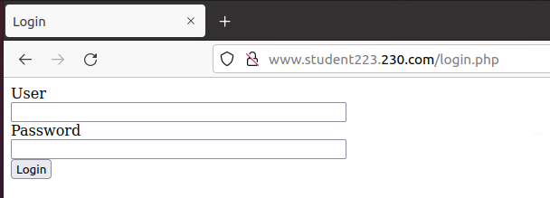

Before this login page works, we need to set up the MySQL database. Our connect.php file will handle authentication with the database. If you are unable to render the login page, something worth trying would be to restart the apache2 service by running sudo systemctl restart apache2

Login Database
Back on the www machine we will create a database and service user to store usernames and passwords.

- Execute the following command to download a few premade MySQL scripts.

sudo scp repo230@homework.230.com:~/lab08/part1/*.mysql /home/cpre230/

- If you aren't already in your home directory, go there with cd /home/cpre230.
- Create a MySQL database, user, and table with the following command.
sudo mysql < create_table.mysql
- Insert the users with:
sudo mysql < insert.mysql
- Verify that the database and tables have been created by running the following commands.
sudo mysql
show databases;
use login_info;
show tables;
select * from UsernamePassword;
You should see the newly created usernames and passwords.
- Exit from the MySQL prompt.
quit;

Test the Configuration
connect.php takes the entered username and password from login.php, queries the MySQL database, and checks to see whether the given credentials exist within the table. If the returned statements are not empty then the user is authenticated and granted access to the system. For now, connect.php just displays "Login Successful" or "Login Unsuccessful". When we add the profile.php script in later steps, we will redirect the user to a basic profile page on successful authentication.

- Now visit www.studentXX.230.com/login.php from your desktop machine and log in using one of the usernames and passwords found in the insert.mysql file. We recommend using bgates because the password is easy to type. Take a screenshot of the page once you are logged in.

Setting Up SSL
Up until now, we’ve been operating with the HTTP protocol over port 80 with unencrypted traffic. All login credentials can be seen in plaintext, similar to how the email server was initially set up.

- From your desktop box, start Wireshark and capture traffic while logging into your website in Firefox. (You may need to hit the back button to login again) Filter for HTTP traffic in Wireshark, and then look through the HTTP packets to find the credentials you logged in with. Take a screenshot of the password in plaintext.
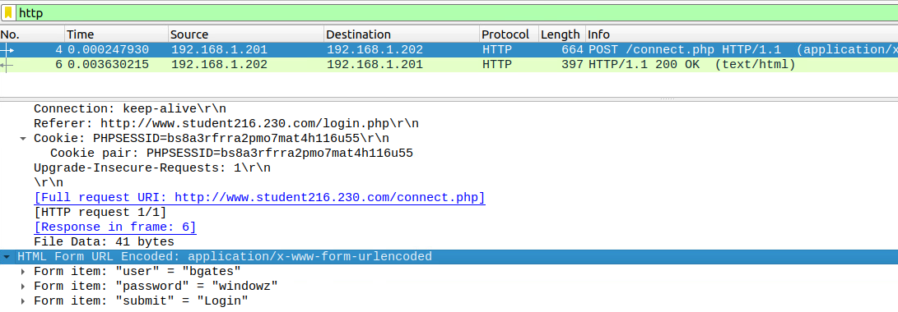

To mitigate this, we will set up HTTPS, which transmits traffic over SSL/TLS on port 443.
- Make a self-signed SSL Certificate. From your www box, perform the following instructions.
  - sudo mkdir /etc/apache2/ssl
  - (all on one line) sudo openssl req -x509 -nodes -days 365 -newkey rsa:2048 -keyout /etc/apache2/ssl/www.studentXX.230.com.key -out /etc/apache2/ssl/www.studentXX.230.com.crt
  - You will then have to enter the following information related to the generation of your certificate.

Country Name: US
State or Province Name: Iowa
Locality Name: Ames
Organization Name: Iowa State University
Organizational Unit Name: CprE230
Common Name: www.studentXX.230.com
Email Address: cpre230a@studentXX.230.com

  - Next, open the following config file.
sudo vim /etc/apache2/sites-available/default-ssl.conf
  - Add the following lines in the default-ssl.conf file (the line after ServerAdmin is a good place).
ServerName studentXX.230.com
ServerAlias www.studentXX.230.com
  - Change the following lines in the default-ssl.conf file.
SSLCertificateFile /etc/apache2/ssl/www.studentXX.230.com.crt
SSLCertificateKeyFile /etc/apache2/ssl/www.studentXX.230.com.key

  - The file should look similar to the following:
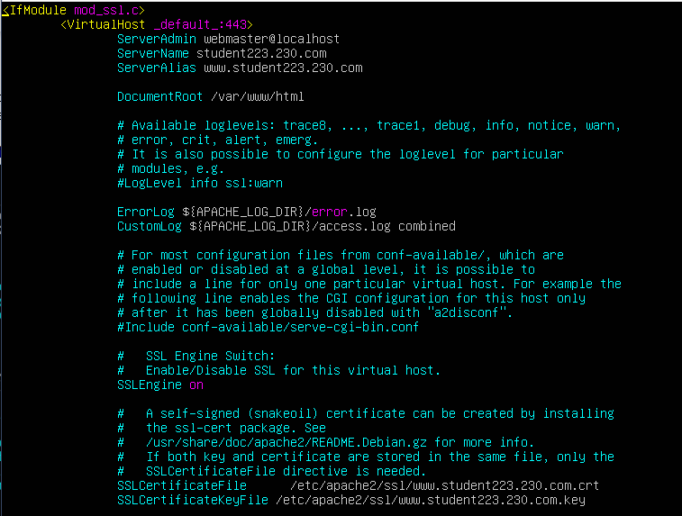
- Activate the SSL Configuration by running the following three commands:
sudo a2enmod ssl
sudo a2ensite default-ssl.conf
sudo systemctl restart apache2
- Test the SSL Connection.
  - Visit https://www.studentXX.230.com from your desktop.
  - Because we are using a self-signed certificate, you will be prompted with an insecure connection page. This just simply means that the connection is indeed being encrypted, but that the certificate being used to encrypt the connection was not issued by a trusted vendor. We will now view the certificate being used, to verify that it is indeed our own.
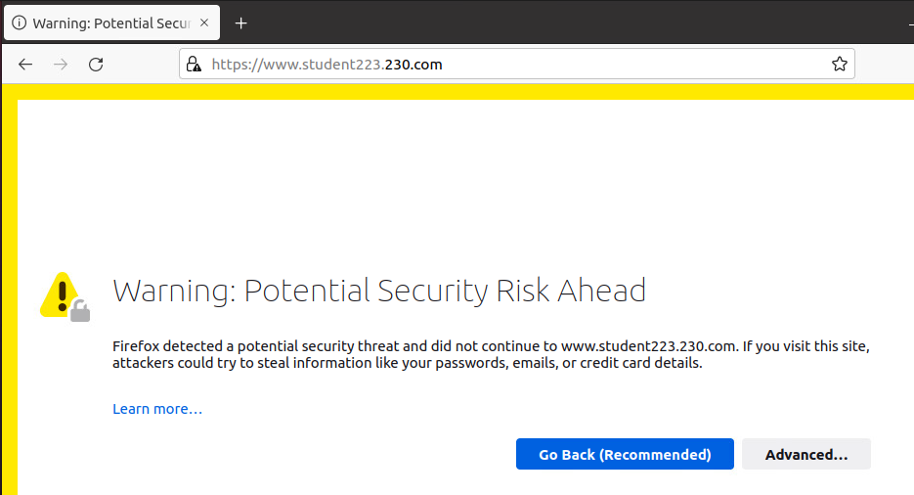

  - Click "Advanced...".
  - Click "Accept the Risk and Continue".
  - You will now see the default web page on your web server. Take a screenshot.

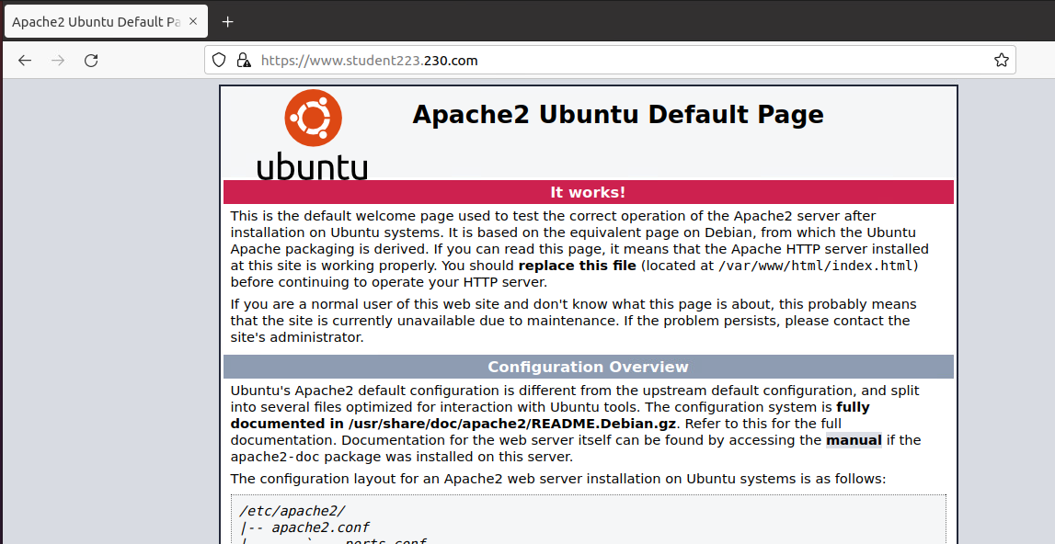

- Look at the certificate.
  - Click the padlock icon in the address bar.
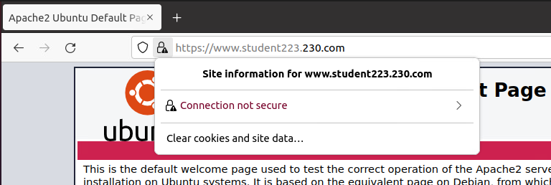
  - Click the arrow to the right side of the "Connection not secure"
  - Click "More Information" at the bottom.
  - Click "View Certificate" and you should see a screen similar to the screenshot below. Take screenshot.
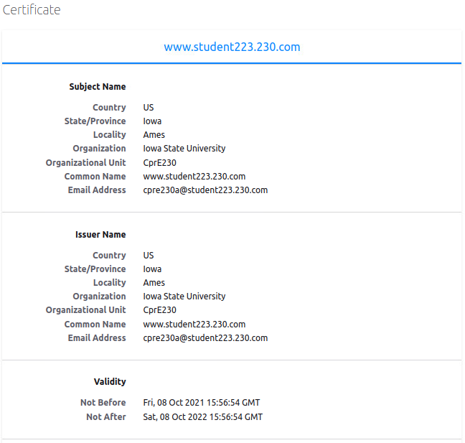

- Start Wireshark and capture traffic with a display filter of tcp.port==443.
- Open Firefox and log in from https://www.studentXX.230.com/login.php.

You should no longer be able to see the password in plaintext. All the data should be encrypted. Look through the packets to see how little information is in plaintext. Take a screenshot inspecting any packet from the TLS connection .

Web Expansion
Now that we have a very basic login page let's add additional functionality, namely a profile page and mechanisms for changing our username and password.

- Again, we will be downloading additional scripts from the repository in a similar fashion as earlier in the lab. Execute the following command (from your www server). Again, the password is repo230.

sudo scp repo230@homework.230.com:~/lab08/part2/*.php /var/www/html/

- This will add 5 additional php files to /var/www/html/, the root directory of your website.
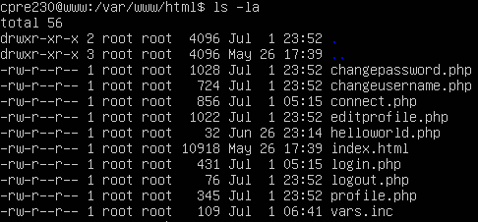

- Taking a brief glance at these new scripts, we can understand what is going on behind the scenes.
  - profile.php ⇒ We simply evaluate the $username variable to display the user's name and then offer a link to the editprofile.php script.

  - editprofile.php ⇒ Similar to the login.php script, this takes data from various input fields and passes it along to either the changeusername.php or changepassword.php script.

  - changeusername.php & chagepassword.php ⇒ Both changepassword.php and changeusername.php are very similar, in that they submit queries to the MySQL server to either update the user's username or password.

- Now, when we login with valid credentials, we should be faced with a basic profile page. Remember that the login page is at https://www.studentXX.230.com/login.php. Do this on your desktop and take a screenshot.
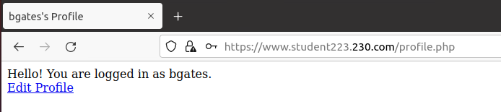

With our new and improved site, let's look at forced authentication.

SQL Injection
- On the existing login page (after logging out), you can force authentication by typing anything in the username field and the entire line below in the password field.
password' OR '1' = '1

- How this works:
This SQL injection works because of the way SQL statements are structured. We lose the leading and trailing ‘ from our SQL injection because we’re tricking the database out of evaluating our password input as a single string; instead of querying the user database for the string ‘password’, where password is our field input, it is now querying for the full statement ‘password’ OR ‘1’ = ‘1’. No matter what we do, when we have an OR statement that is true, MySQL will automatically query every single entry in the database. Since '1' = '1' is always true, this is why we can query all the entries. From these database entries, the PHP script will grab the first entry's username and password and "log in" with those credentials.

- Using the above steps, log in as one of the existing users without using the supplied password via the above discussed SQL injection.

- Click "Edit Profile" and change the username to one that is not currently in the system ("sjobs" -> "steve", for example).
- In the current password, type in the current password of your chosen user.
- In the new password, update the field to whatever you wish.

- On the web server, run the following commands.
  - sudo mysql
  - select * from login_info.UsernamePassword;
- This should show the updated database entry with the new username and password. Take a screenshot.

As part of your submission, please reflect on what the underlying issue is with SQL injection and how you might go about fixing it; you will have to do so in a later lab (4-5 full sentences.) Removal of the files is not an option.

Add Rules for WWW for Outside/Nagios Check
- From your desktop machine open Firefox and open the pfSense web configurator. If you don’t remember how to do this, return to Lab 04.
- Add the appropriate NAT rule(s) in pfSense that allows the outside world, as well as Nagios, to view the web pages.
  - You can use the instructions from Lab 05 to determine what fields to complete, but you will need to know what protocol to use, as well as the correct IP addresses and ports.
  - Like the mail server, you want the outside world to have access, so you won’t limit the source to just the Nagios machine’s IP.
  - You need to allow all machines to connect to the webserver, but just for using web pages and the services (like mysql or the php files) they are providing.
  - If you have questions, you can ask your TA for help. However, you should be able to think through these options on your own.
  - Include a screenshot of your successful NAT rule.
- Go to Nagios and check if it can see your web server. If you can’t remember how to get to Nagios, you can find the instructions in Lab 05. You may have to adjust your firewall’s NAT rule if you are unsuccessful.
- Include a screenshot of your successful NAT rule(s).
- Include a screenshot of the Nagios status showing all www services are functioning for your domain.

